# AMAZON ELASTIC COMPUTE CLOUD (EC2)

**To connect running AWS EC2 instance through Command Prompt (cmd)**

**Step1:** EC2 Instance Details **(Manually Installation on Launch)**

* Open AWS Management Console → Go to EC2 Dashboard.
* Click on **Instances** and find your running instance.
* Note down the **Public IPv4** address or Public DNS.
* Make sure **port 22 (SSH), HTTPS, HTTP** is open in your security group.

**Step2:** Open command Prompt through keypair locations

1. Connect to EC2 Instance using SSH

**ssh -i "your-keypair.pem" ec2-user@public-ip-address**

1. To confirm SSH connection type **yes to continue**

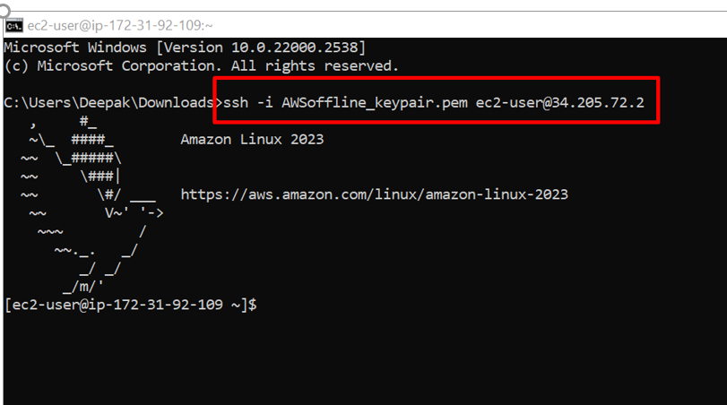

**Step3:** Command to switch to root user 🡪sudo su

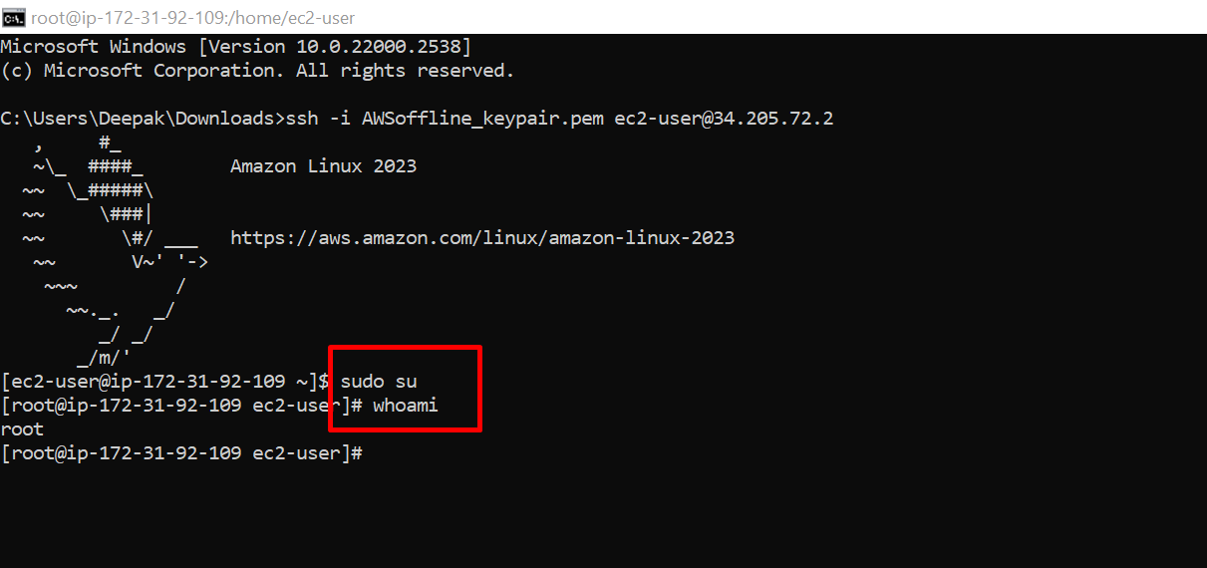

**Step4:** Command to install httpd 🡪 yum install httpd -y

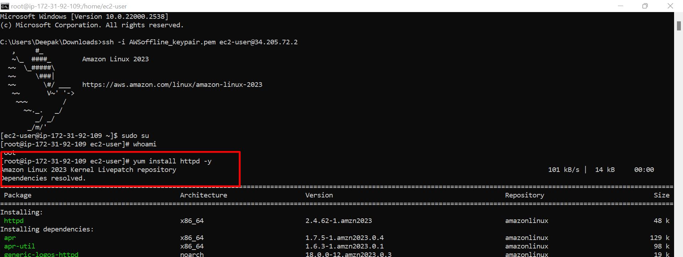

**Step5:** Command to check the status of httpd 🡪 systemctl status httpd

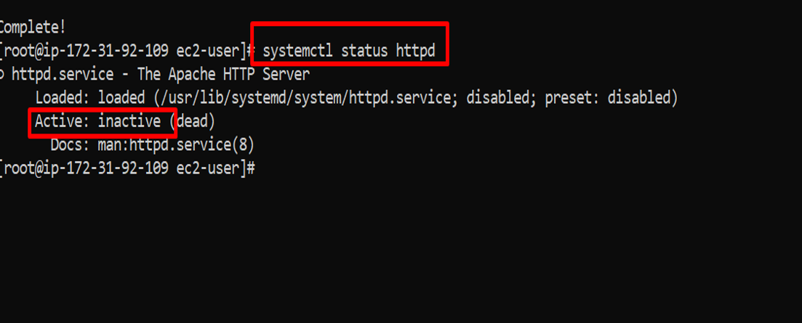

**Step6:** Command to enable the httpd 🡪 systemctl enable httpd

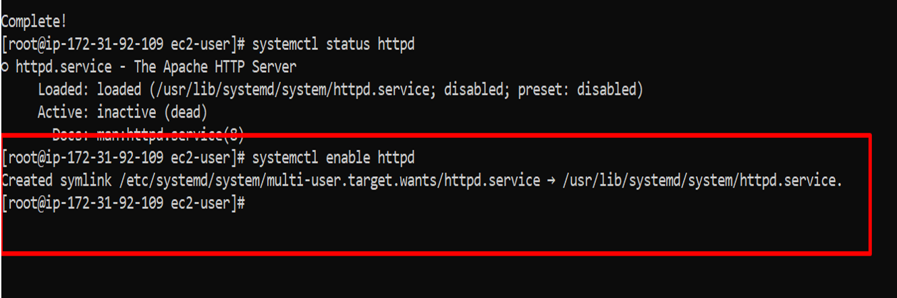

**Step7:** Command to start the httpd 🡪 systemctl start httpd

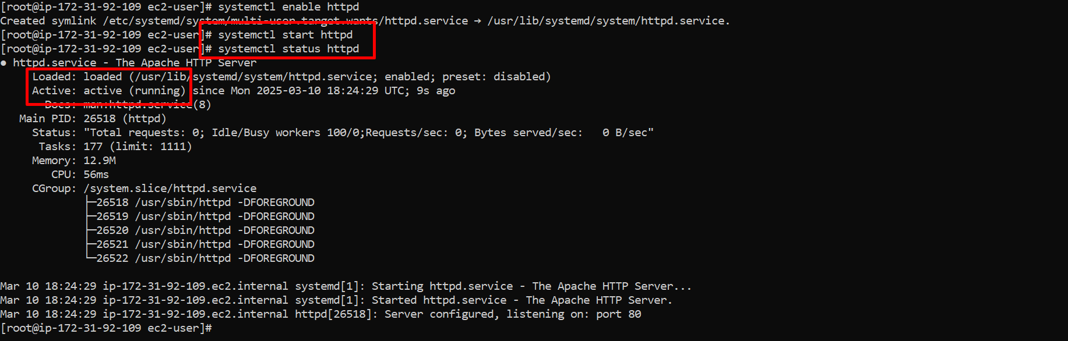

**Step8:** To print message in html content **echo "<h1> Hello everyone </h1>" > /var/www/html/index.html**

* echo "<h1> Hello everyone </h1>" → Outputs the HTML content
* **> →** Redirects the output to the file /var/www/html/index.html.
* If /var/www/html/index.html exists, it will be **overwritten.**

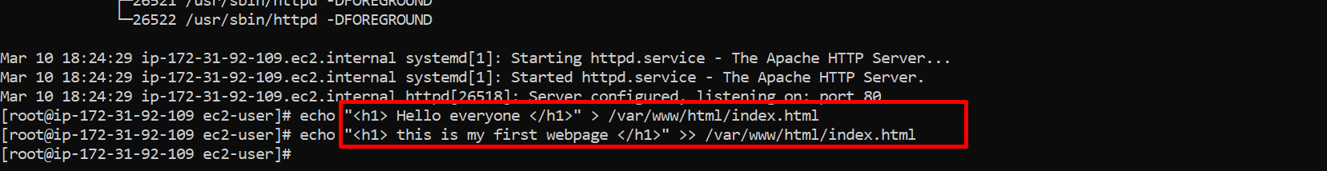

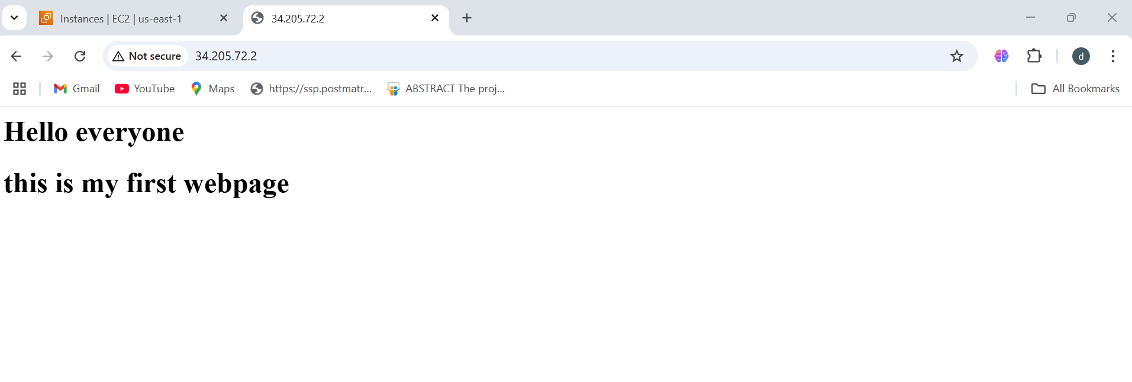

**To connect running AWS EC2 instance through ec2 console**

The shebang **(#!)** itself is not an installable package; it is a syntax used in script files to specify the interpreter. However, if you mean installing **Bash (/bin/bash)**, Zsh, or other shells in EC2 instances automatically, you can do so via **User Data** or a configuration script.

**Step1:** Using EC2 User Data (Automatic Installation on Launch)

* When launching an EC2 instance, you can specify user data to automate installation.

**Step2:** For Amazon Linux

* Go to the AWS Console 🡪 Launch an EC2 instance 🡪 Under "Advanced Details" 🡪 "User Data," enter:

**Commands:**

#!/bin/bash

yum install httpd -y

systemctl enable httpd

systemctl start httpd

echo "<h1> hello this is user data </h1>" > /var/www/html/index.html

